Weapons Compliance Review Hearings

ALL Protection Order and Weapons Compliance Review hearings will be conducted by phone. Do not come to court in person! Below is a quick checklist to help respondents better understand how to comply with the Order to Surrender Weapons and how to participate in telephone Weapons Compliance Review Hearing.

In order to appear at your scheduled hearing, please contact the court at the following email address at least one day before your hearing: weapons-surrender@kingcounty.gov
Please be sure to include in your email the following information:
✓ Your full name
✓ Date of your review hearing (this can be found in the upper right-hand corner of the Order to Surrender Weapons Order)
✓ The case name (for example: Smith vs. Smith)
✓ Your case number (this can be found in the upper right-hand corner of the Order to Surrender Weapons, for example: 19-2-12345-6)
✓ A good phone number where you can be reached between 8:30am and noon on the day of your review hearing

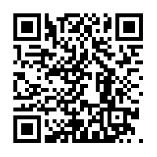
For more information about how to be in compliance with the Order to Surrender Weapons, please click on or search for the following link through your web browser: https://bit.ly/3d9gHE4 or scan the QR code with your smart phone:
Court forms mentioned in the video, including the Declaration of Non-Surrender form (WPF All Cases 02-070) and the Proof of Surrender form (WPF All Cases 02-060), can be found at https://tinyurl.com/w7ou6ed

